

**Stock Trading with Machine Learning**

**Daniel Hunegnaw , Kai Luo | EE P 596 Advanced Machine Learning | 02-27-22**

Contents

Introduction 2

Project Structure 2

Folder structure 2

Stock ML Model with EMA 5

Feature and Label Extraction 5

Performance Evaluation backtest 6

Results 6

Stock ML Model with STL 9

Process steps 9

Performance Evaluation backtest 9

Results 10

Github Project Location 12

Conclusion 12

References 12

Contribution 10

# Introduction

In this report, we will present the implementation of the baseline cross moving average strategy for stock trading.

# Project Structure

The project is implemented in python using visual studio code. A private repository is created in github. We have planned to make the repository public after the project is completed. Fig 1 below show the current structure of the project. Below is provided a brief description of each folder and file.

## Folder structure

stock-ml-mini-project: The root folder of the project

docs:- where documentations and reports of the project reside

docs-report -final.docx:- the final project report document

src :- where the source code of the project resides

TradingStrategy.py:- class which contains all the functionality to do paper trading with trained model

program.ipynb:- a jupyter file for running model training and back testing. To run the project using the program.ipynb, you need to provide values for **Api_key** and **Secret_key** variables.

PaperTrader.py:- class/a job for running paper trading everyday when the market is open

start.py : this does the same task as in program.ipynb but you can use this to run it from the command line using the command as in the Fig 2

Common:- Is a folder that contains common utility classes

ApiClient.py:- a utility class used to call the ALPACA API

DatetimeUtilty.py:- used to check if the market is open for trading for a given datetime

MovingAverageCalculator.py: contains functions for calculating Simple and Exponential Moving Average

MA:- Contains class files related to moving average functionality

BaseStrategy.py: a base class which currently contains functions for:

* plotting dataframe data, moving averages, buy and sell signals
* for generating buy and sell signals based on crossing moving averages

ExponentialMovingAverageStrategy.py : a class which contains functions for

* generating data for exponential crossing moving average based strategy
* creating features and labels based on local min and max of the moving average
* training models
* backtesting models

SimpleMovingAverageStrategy.py : contains function for generating data for crossing simple moving average-based strategy

STL:- Contains class files related to STL functionality

StlMl.py: a class which currently contains functions for:

* generating features and labels based on STL from raw
* train STL ML training model
* predict models for every buy, sell and hold possible
* regulate models for sanitize extra buy and sell and prevention of excessive losses
* produce profit model
* plot model for close price and prediction
* backtesting model

Fig 1. Project structure



Fig 2. Running the project from command line

# Stock ML Model with EMA

## Feature and Label Extraction

The following are the steps used to create features and labels

1. Calculated the 20-days exponential moving average
2. Based on the moving average local *min* and *max* are calculated with sliding window of 4 (default) on the close price
3. The local *min* and *max* of values are used to generate the label the *signal* column. A signal value of 1 means ‘buy’ and a signal value of -1 means ‘sell’
4. Then the data is divided into int train and test (7 months of data for train, and the last 5 months of data for backtesting
5. Modeling training is done on the data which looks like as shown in Fig 3.

Fig 3. Except of the dataframe with features columns Min, Max, and label Signal

## Performance Evaluation backtest

The data selected for this project includes one year stock data of FB, MSFT, NFLX, AMD, and GOOG. Of these data, 7/12 of the data used for training and the remaining(5/12) is used for backtesting.

In order test the performance using log returns, we assumed to buy just a single unit of the stock based on the signal. For this purpose, after the model was trained, we introduced a column “*position*” whose value of 1 represents one unit of the stock and 0 represents no position on the stock

To evaluate the performance of our machine-based model, we compare the return of the ML strategy with the naïve approach of buy and hold for a certain period , in this case for 5 months. To this end, for the last 5 months, we calculate the log returns , *ln(Pt+1/Pt)* , for each day and put it in the column “*daily_profit*”. The return for the ML based strategy is derived from the “*daily_profit*” and “*positions*” column using the formula

strategy_profit = daily_profit * positions

Fig 4. below shows the final column structure of the data after the backtesting is done. The signal column the test data contains the predicated values

Fig 4 Showing returns (daily_profit) for buy-and-hold, and strategy_profit for the EMA ML strategy

## Results

The results for each stock are shown below in the screenshots. Each of the Figs (5, 6, 7, 8,9) shows the following

1. 7 months of training data showing close price (black), 20-days exponential moving average(magenta), labels sell (red triagle), buy (green triangle)
2. 5 months of backtest data showing close price (blue), 20-days moving average (cyan), predicted labels – sell (light red) and buy (light green)
3. Shows at the bottom of the fig the returns of each strategy

Fig 5. Train and backtest data results for FB

Fig 6. Train, backtest results for AMZN

Fig 7. Train, backtest results for MSFT

Fig 8. Train, backtest results for GOOG

Fig 9. Train, backtest results for AMD

# Stock ML Model with STL

## Process steps

The following are the steps used to create features and labels

1. Split 255 days (one year) data set to train and test
2. Calculated the Seasonal and Trend decomposition using Loess(STL)
3. Based on the residual histories of last n day, last close and open price as features
4. Based on the mean of residual divide to three parts as sell/hold/buy as labels
5. Train and test with linearSVD ML
6. sanitize prediction limited buy and sell point and prevention of excessive losses
7. Profit calculation based on *ln(sell price /buy price)*

## Performance Evaluation backtest

1. Split 255 days (one year) data set to train and test
2. Train for 7 months and test for 5 months
3. Transfer each to get features and labels
4. Train and test with STL ML

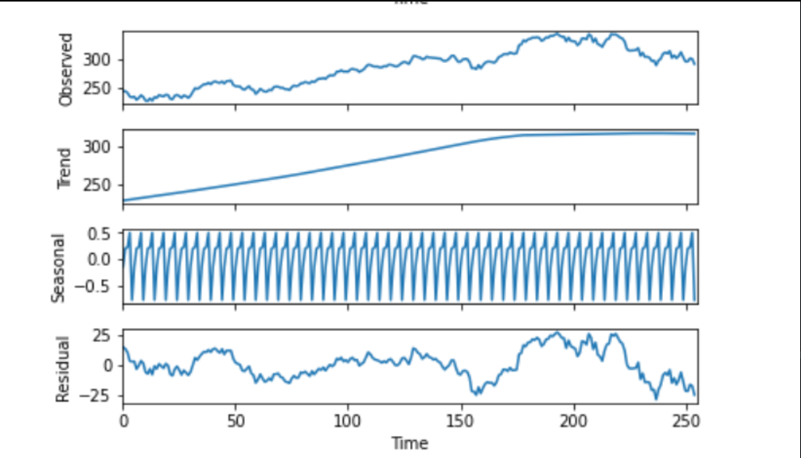

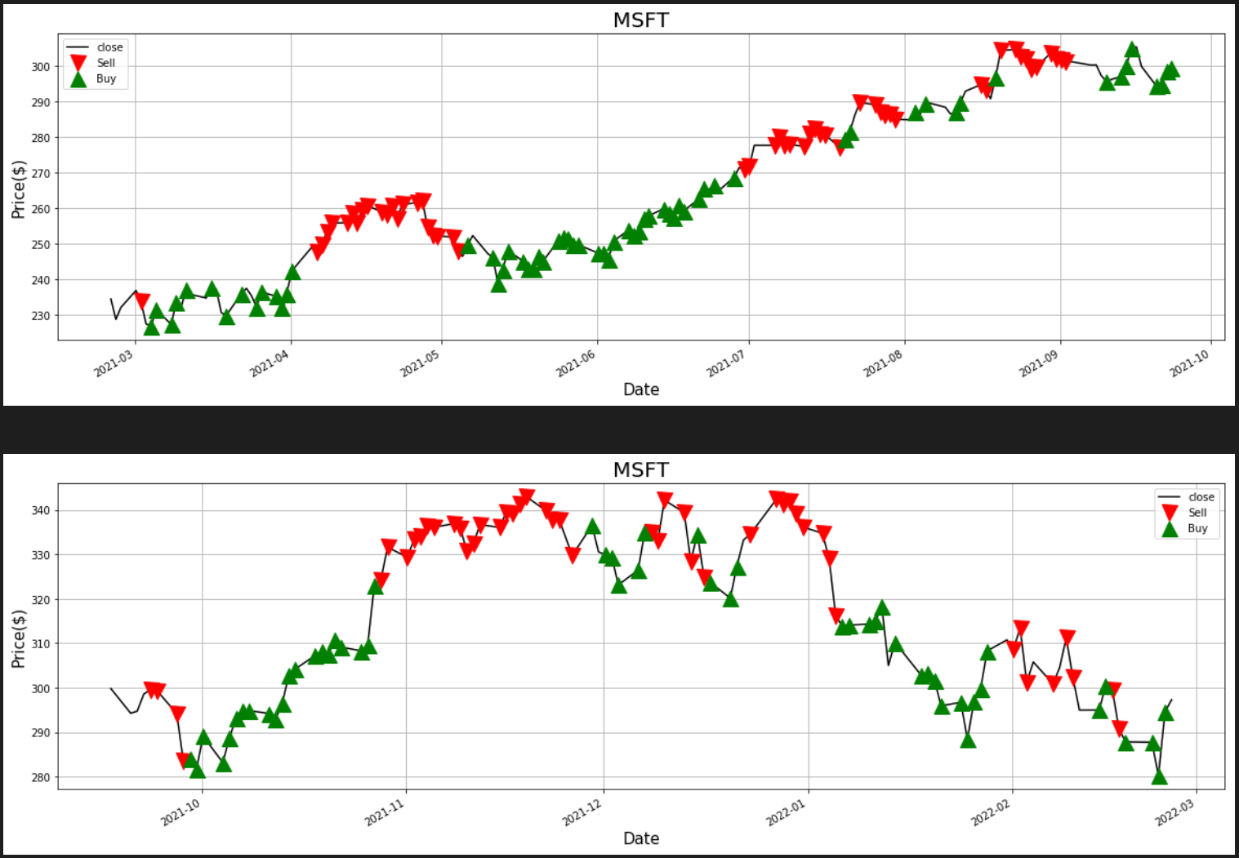

Fig 9. Train, test labes for GOOG

## Results

The results for each stock are shown below in the screenshots. Each of the Figs (10, 11,12, 13,14) shows the following

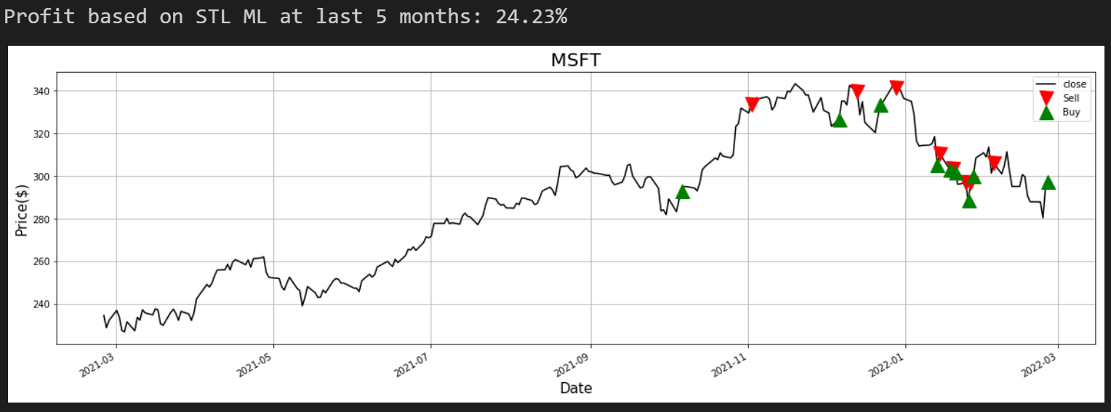

Fig 10. result for MSFT

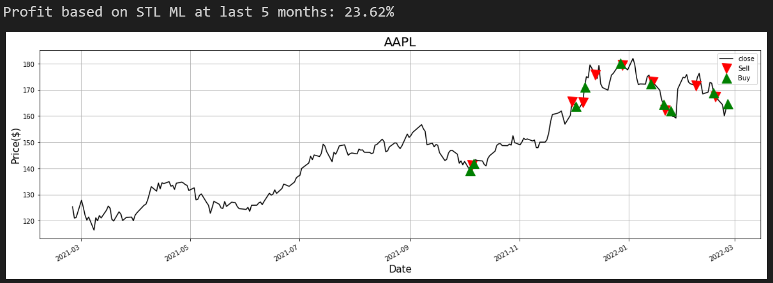

Fig 11. result for AAPL

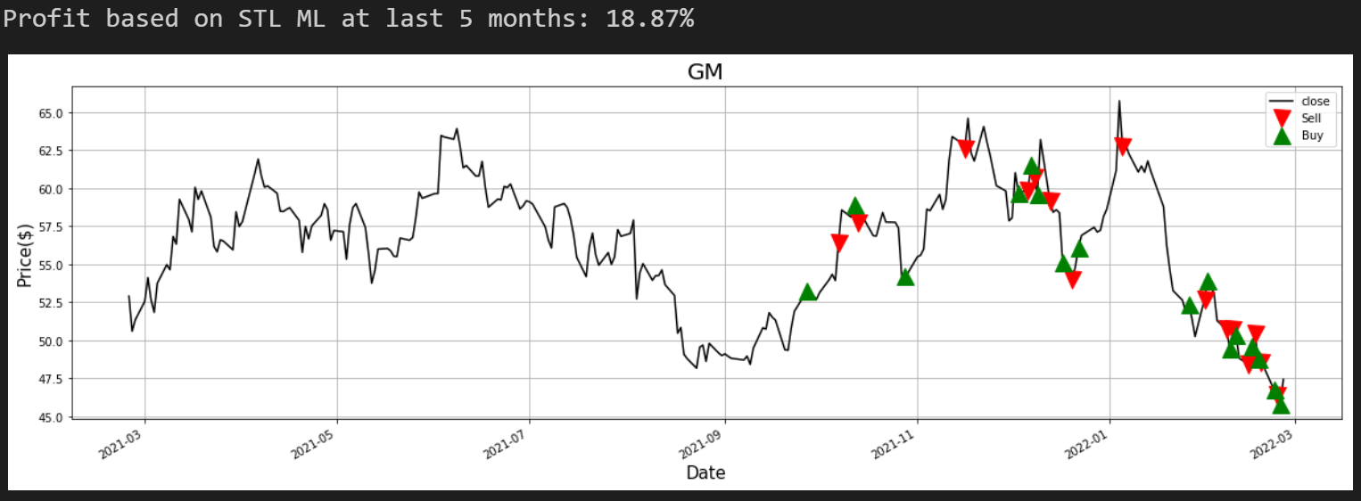

Fig 12. result for GM

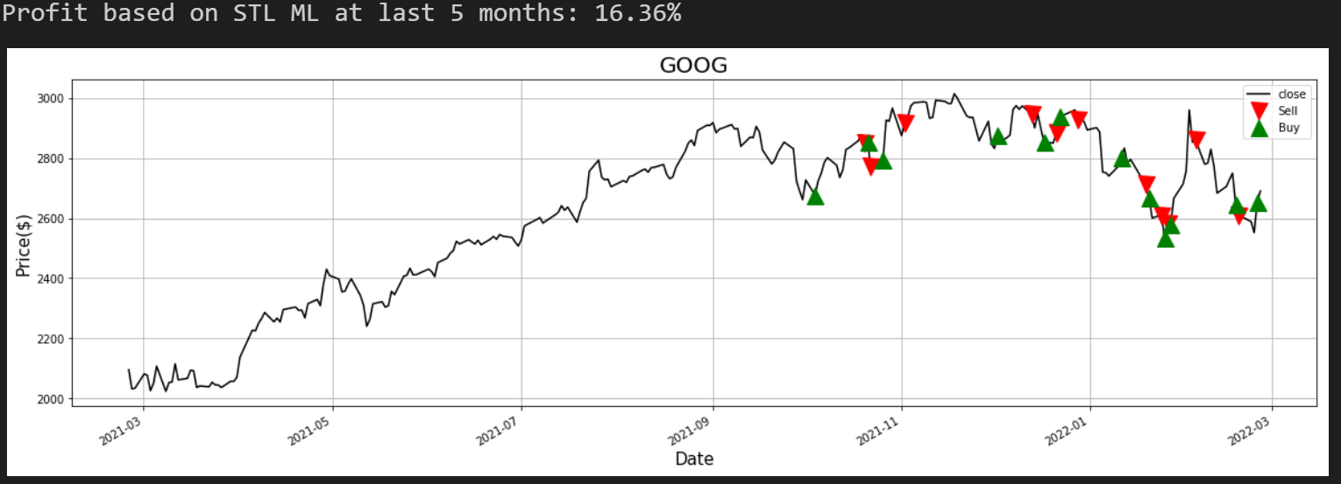

Fig 13. result for GM

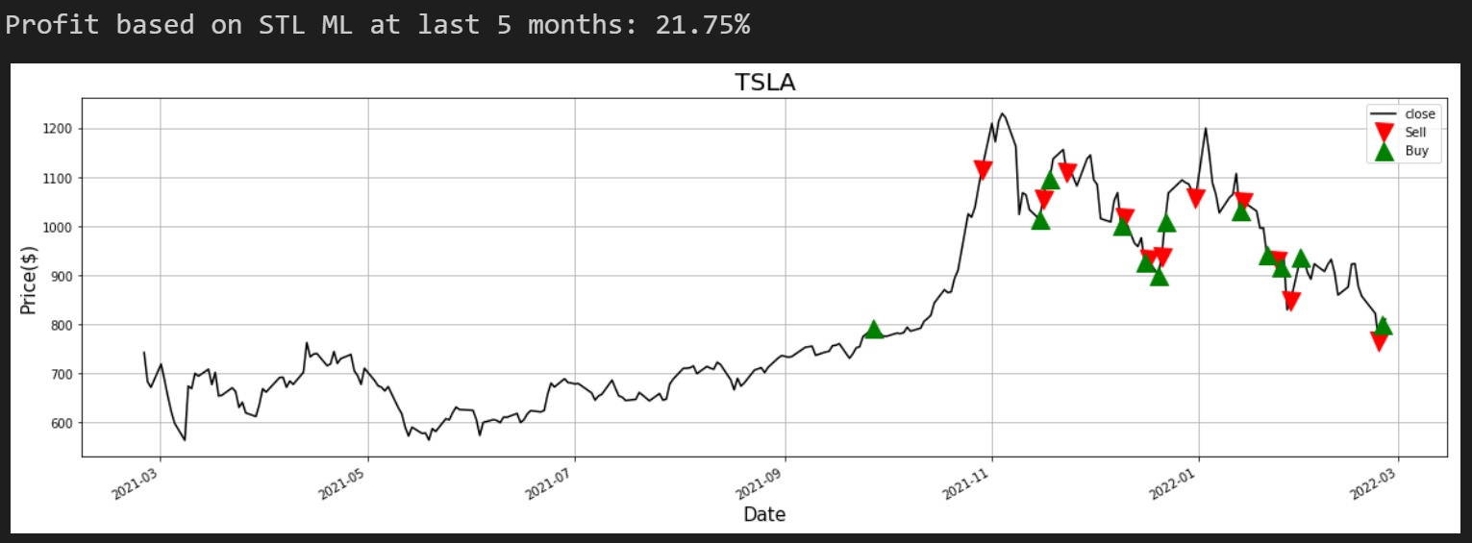

Fig 14. result for TSLA

Total profit: 104.8%

# Github Project Location

Throughout the project, github is used a code and collaborative repository. It was just private repo , we just made it public

<https://github.com/danielhunex/stock-ml-mini-project>

# Conclusion

In the case of performance metrics, comparing buy-and-hold strategy for a short period (5 months) of time might not be a good baseline (or a naïve approach) to compare with the EMA ML based strategy; however, it has satisfactorily proved how the strategy well performed.

STL is typically used for anomaly detection, which breaks the sequence into three components: seasonality, trend, and remainder. Essentially a standardized version of the original series, so this is what we monitor for exceptions. Using STL for stocks is a novel but logical thing to do. Essentially, if a company is healthy, its stock should rise or fall regularly. When something unexpected happens, the company's stock will react faithfully. Abnormal reactions can be detected by residual forces. Then by setting the residual threshold, people can sort out and understand the trend of the stock. Sort out the label by setting the lower zone for buy, the middle zone for watch, and the upper zone for sell. Finally, through them to machine learning, a pipeline of stock anomaly detection can be established. This applies to the majority of stock price cycle obviously abnormal fluctuations of the small range of stocks.

# References

<https://docs.scipy.org/doc/scipy/reference/generated/scipy.signal.argrelextrema.html>

<https://www.freecodecamp.org/news/algorithmic-trading-in-python/>

<https://algotrading101.com/learn/alpaca-trading-api-guide/>

<https://medium.com/wwblog/anomaly-detection-using-stl-76099c9fd5a7>